HIT-APSCO
Full English PhD Program 2024

Introduction to Harbin Institute of Technology
Harbin Institute of Technology (HIT) was established in 1920 in Harbin, Heilongjiang, China. In 1954, HIT became one of China’s first six leading universities. Presently HIT is a member of China’s top nine University Union (C9). It is a National Key University with science and engineering as its core and has developed to include management, liberal arts, economy, law and other disciplines. In the US News ranking for the Best Global Universities for Engineering, HIT ranked No.2 in China and No.5globally.

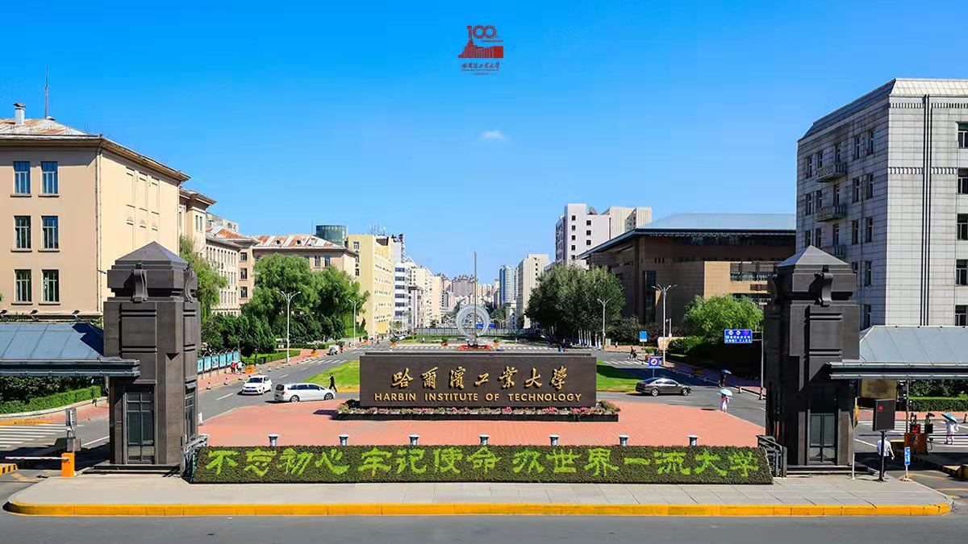
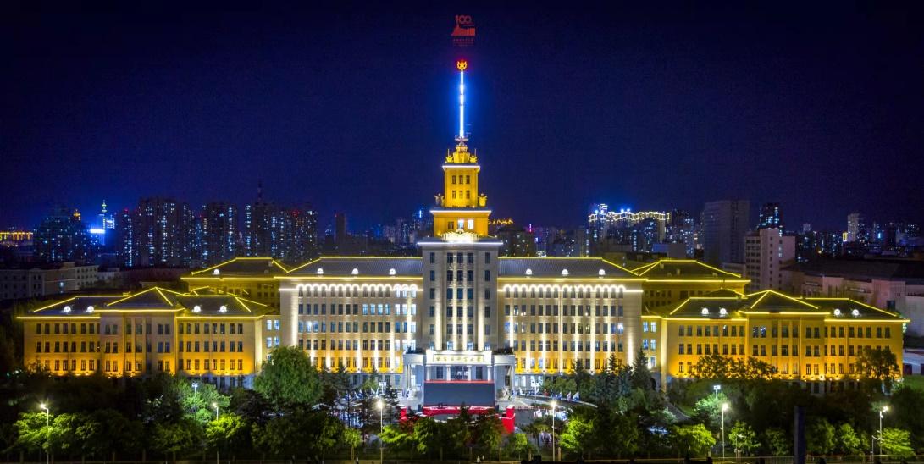
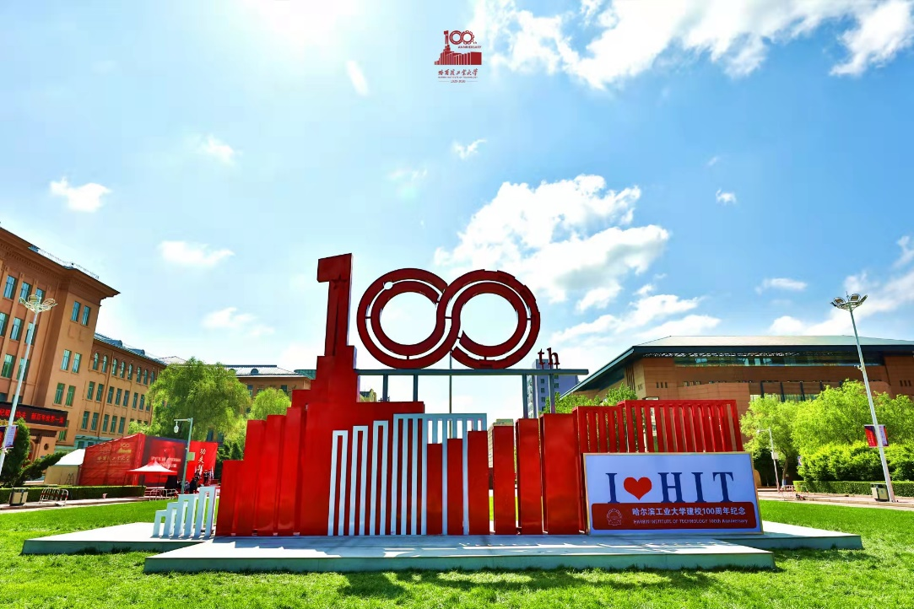
Available Disciplines & Research Fields
Schools | Disciplines | Research Fields
Astronautics | 0811  Control Science and Engineering | 1. Navigation, Guidance and Control  2. Control Theory and Control Engineering  3. Detection Technology and Automatic Equipment  4. Robots and Intelligent Systems  5. Systems Engineering and Simulation
 | 0801  Mechanics | 1. Fatigue and Fracture Mechanics  2. Structural Optimization Design  3. Micromechanics  4. Solid Dynamics  5. Thermo/Mechanical/ Electrical/Chemical Multi-field Coupling Mechanics  6. Material and Structural Mechanics in Extreme Environment  7. Advanced Composites and its Structural Lightweight Theory  8. Composite Materials and its Structural Mechanics  9. Reliability Analysis and Design of Composite Structures  10. Intelligent Materials and Structural Mechanics  11. Aerospace Structural Mechanics  12. Material/ Structure/ Function Integrated Design  13. Structural Dynamics and Vibration Control  14. Nonlinear Dynamics  15. Hydrodynamics  16. Dynamics Inverse Problem and Fault Diagnosis
 | 0825  Aeronautical and Astronautical Science and Technology | 1. Aircraft System Design  2. Flight Dynamics and Control  3. Aircraft Intelligent Autonomous Navigation, Guidance and Control  4. Deep Space Flight and Landing Return  5. Integrated Design and Simulation of Aircraft  6. Dynamics and Control of Complex Spacecraft  7. Space Environmental Effects of Spacecraft and its Countermeasures  8. Structure and Protection of Aerospace Vehicles
Mechatronics Engineering | 0825 Aeronautical and Astronautical Science and Technology | 1. Space Structure and Control  2. Aerospace High Precision Manufacturing Technology  3. Space Robot Technology  4. Space of Special Processing Technology  5. Aircraft Digital Manufacturing Technology  6. Aircraft Ground Simulation and Testing Technology
 | 0802  Mechanical Engineering | 1. Precision and Ultra-Precision Processing Technology  2. Micro-Nano Manufacturing Techniques  3. Special Processing and Special Material Processing Technology  4. Modern Design Theory and Method  5. Digital Design and Manufacturing Technology  6. Mechanical and Electrical System Control and Automation  7. Modern Sensor and Testing Technology  8. Fluid Flow Control and Automation  9. Robot Technology and System  10. Special Transmission Intelligent Design and Control  11. Tribology Basic Theory and Application Technology  12. Engineering Structure Design and Analysis  13. Vibration and Noise Control  14. Biomechanical Engineering  15. Production System Automation Technology  16. Manufacturing System Engineering Management  17. Vehicle Dynamics and Control  18. Vehicles Advanced Manufacturing Technology  19. Modern Design Theory and Method Of Vehicle  20. Vehicle Electronics and Control
Introduction to the School of Astronautics
The School of Astronautics, approved by the Ministry of Space Industry in June 1987, was founded by the merger of the Department of Control Engineering, the Department of Radio Engineering, the Department of Engineering Mechanics and Flight Vehicle System Designing Office. It is China’s first higher education institute which mainly focused on the education of specialists and research in the field of astronautics. The school is also the only affiliate of International Space University in Asia.
In the early 1990’s, both laser and optical engineering specialties were incorporated into the school. Through the support of the Ministry of Space Industry as well as the assistance from China Academy of Space Technology (CAST), the school established the earliest specialties on satellite and spacecraft environmental engineering in China. In 2009, the former Department of Radio Engineering independently formed its own school. The school presently oversees 12 departments and research centers offering 10 astronautic-related undergraduate majors spanning 6 primary disciplines and 15 subordinate disciplines. As the most competitive School of Astronautics in China, we offer outstanding opportunities to cultivate talent and conduct innovative and leading-edge scientific research. Through its strong leadership, specialty knowledge and experience, as well as focus on development, the School of Astronautics is internationally recognized as a driving force for innovation in the astronautics field and quickly becoming a world-class research institute.
Under the efforts made by generations of scholars, the school has gradually built up a profound academic foundation and developed a qualified group of distinguished scholars and well-known specialists. The paragon for the intellectuals today, Ma Zuguang has been praised as the top representative of the educators in HIT. At present, there are 140 professors among 400 staff members, including:
7 academicians of Chinese Academy of Engineering / Sciences
13 Cheung Kong Scholar professors
4 Visiting professors
9 winners of the National Outstanding Youth Foundation(including foreign nationality)
2 national famous teachers
2 innovation group of the Chinese National Natural Science Foundation
4 innovation groups of the Ministry of Education
3 innovation groups of national defense science and technology
In summary, the School of Astronautics ranks high both in education and research.
The school has established a close relationship with research institutes in both China Aerospace Science and Technology Corporation and China Aerospace Science and Industry Corporation. Through cooperation with these institutes, the school has established the first Astronautics major in China, set up Internship Base for students, and invited several specialists as visiting professors, including the chief designer of Chinese Lunar Orbitting Detection Project Sun Jiadong, and the chief designer of Chinese Manned Spaceflight Project Wang Yongzhi.
Additionally, our school’s close collaboration with PLA General Armament Department and the Second Artillery Force has greatly contributed to the construction of national defense.
The school actively undertakes international exchange through communicating and cooperating with related departments in more than 20 universities worldwide. The school has also invited 5 long- term overseas visiting specialists, and 17 overseas honorary specialists to share knowledge with students. In the past 3 years, the school has held about 10 international academic conferences, and has invited nearly 100 foreign specialists to give lectures. Additionally, nearly 100 HIT teachers have attended overseas international academic conferences, and more than 40 excellent young teachers have taken further studies at universities around the globe.
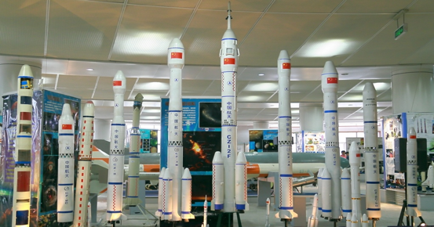
Introduction to the School of Mechatronics Engineering
Mechanical Engineering is one of the oldest disciplines, which was built up at the beginning of HIT in 1920, and is also one of the first established related disciplines in China. After decades of development, the School of Mechatronics Engineering currently comprises 15 departments and research centers. The discipline of Mechanical Engineering ranked No. 2 in 2002 and No. 4 in 2006 respectively at the academic assessment of the Ministry of Education, and was approved as the national key discipline in 2007.
The school is on a clear path to become a world-class school of Mechanical Engineering.
Mechanical Engineering is one of the oldest disciplines, which was built up at the beginning of HIT in 1920，and is also one of the first established related disciplines in China. After decades of persistent efforts and development, the School of Mechatronics Engineering has reached the following scale: it currently comprises 14 departments and research institutes (centers), the Engineering Graphics Section, the Departments of Mechanical Design. Mechatronic Engineering, Fluid Control and Automation, Manufacturing Engineering, Engineering Machinery and Logistics Technology, Industrial Design, Industrial Engineering, Aircraft Manufacturing, as well as the Engineering Training and Metal Technology teaching and research Center, the National Key Lab of Robotics and Systems, the Center for Advanced Production Technology, the Institute of Precision Engineering, and the Institute of Electro-hydraulic Serve Simulation & Test System.
The School of Mechatronics Engineering cultivates a teaching and research team with reasonable structure, active in academic thinking and excellent comprehensive quality. Until now, the school has a faculty of more than 460, including 2 academicians of the Chinese Academy of Engineering, 29 high-end talents, like Cheung Kong Scholars, Distinguished Young Scholars and New Century Excellent Talents, which is a team with vitality, high efficiency, and innovation. At present a total of 2,815 students are enrolled in the School, including 1,595 undergraduates, 783 masters' students and 437 doctoral students.
The School of Mechatronics Engineering has outstanding achievement in personnel training and scientific research. In personnel training, the school has cultivated a large number of high-level talents with professional dedication and innovation, which is highly recognized by the society. The employment rate of graduates is above 97% each year. In scientific research, the school has formed a scientific research system organically integrated with basic research, application pre-research, engineering application and industrial development. In the past 3 years, the school made a number of high-level scientific research achievements. It completed more than 580 research projects, with a total funding of exceeding 10 million.
At present, the School of Mechatronics Engineering has established academic links and postgraduate training relations with many other universities and research institutions in the United States, Britain, Japan, France, Germany, Russia, Canada, Australia, Italy, Switzerland, Sweden, Singapore, South Korea, Hone Kong, Taiwan, etc. As to the Department of Manufacturing Engineering for Aviation and Aerospace, it has been the authority to launch MS and PhD program of second-class discipline of Aeronautics and Astronautics Manufacturing Engineering (AAME) from Harbin Institute of Technology (HIT) in 1983 and 2001, respectively. Until now, AAME discipline possesses a key discipline laboratory for national defense for Aerospace Mechanism and Control Technology and a national innovation engineering base for Equipment Design & Manufacture Science and Technology. Furthermore, AAME was approved for key disciplines in Heilongjiang Province in 2007 and it hold advanced conditions of teaching and scientific research and International communication platform. Because of the implementation of scientific and technological plan and national key projects of Large Aircraft, Manned Space and Lunar Exploration Project in China, it leads to the demand of AAME professionals. HIT re-organized the Dep. Of AAME in 2008, which strengthen the construction of AAME discipline, and AMME discipline ranked fourth in subject evaluation of Ministry of Education (2012). Our community has a teaching scientific research strength of the teacher staffs whose knowledge and age structure is reasonable, it includes 18 professors (including 2 part-time professors, 1 overseas consultant professor, 2 distinguished professors, 1 national youth science and technology innovation leader), 8 associate professors and 7 lecturers. Dep. of AAME has excellent experimental conditions for teaching and scientific research. Professional teachers pay much attentions to curriculum system construction, teaching experimental condition construction and education reform. They emphasize on cultivating the practical ability and innovation consciousness of students. In recent 5 years, many teaching achievements have been achieved, including 2 second prizes in National Excellent Teaching Achievement (NETA), 1 first prize and 1 second prize in Provincial Excellent Teaching Achievement (PETA) . Dep. Of AAME pays attention to base and basic applied study. Based on requirement of national defense, aerospace serves, and some basic, frontier and exploratory researches were actively and deeply implemented. Currently, it has formed a research system featuring the aerospace mechanism and control, ultra-precision & special processing and infrared nondestructive testing. The research area is closely combined with national advanced manufacturing and space development program. Dep. of AAME has been responsible for a series of national important science and technology projects, including Lunar Exploration Project II and III, Shen Guang project and so on. Our research and teaching range from aerospace mechanism and control, to highly efficiency precision manufacturing technology, to aerospace robot, to aerospace special processing technology, to ground simulation and testing technology. During 2012 and 2014, Dep. of AAME undertakes more than 50 national scientific research projects and scientific research funds accumulate up to 180 million RMB. It has published more than 200 SCI/EI papers and has been authorized 18 national invention patents. It achieves many achievements, including 1 second prize in National Award for Technological Invention, 1 first prize in the Ministry of Education Technology Invention, 1 first prize in Heilongjiang Province Technological invention and 1 second prize in Heilongjiang Province Natural Science. With respect to international academic exchanges and cooperation, Dep. of AAME carries out a wide range of international academic exchanges and cooperation with Britain, USA, Japan, Germany, Canada, and Russia by organizing or participating in important international conferences, oral presentation and inviting foreign experts to give lectures, cooperative research and so on. So, you're invited to learn more about our research labs and our faculty.
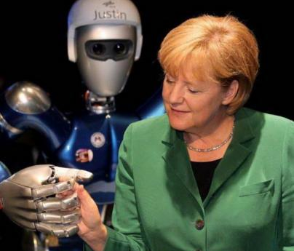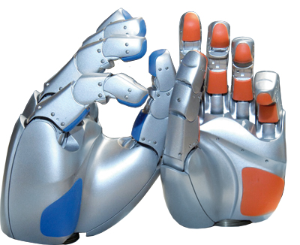
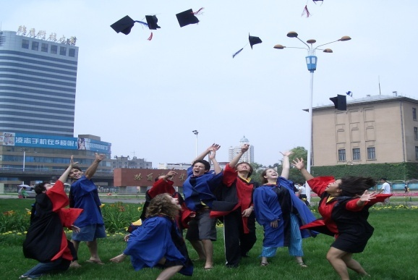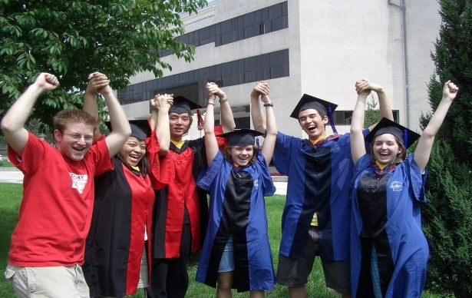
Scholarship and Financial Support
The applicants are welcome to apply for Chinese Government Scholarship (CSC) at Harbin Institute of Technology. The full scholarship will cover the following items:

-Scholarship Coverage
- Tuition fees;
- Free university dormitory;
- Stipend: Granted to the students after their arrival to China and after registration at the school. No stipend is issued before arrival.
Doctoral students: CNY 3,500/month;
- Comprehensive medical insurance: CNY 800/ year
- Duration of Scholarship
The duration of doctoral education lasts 4 years.
-Teaching Language: English

Eligibility
- Be a citizen of a country other than the People's Republic of China, and be in good health both mentally and physically;
- Be a master's degree holder under the age of 40 when applying for doctoral degree;
- Meet the admission requirements of Harbin Institute of Technology in terms of academic ability, language proficiency and other relevant criteria.
Note: Scholarship students are not eligible for other scholarships established by the Chinese Government and admission institutions during the same period.
Application Deadline
Applicants should email all the required documents to the Contact Person at APSCO by January 15, 2024 (the application date is defined as the date on which APSCO receives the email application materials).
Application Procedures and Required Documents
The applicants need to provide the following materials truly and correctly (one set).
All the application documents in other languages must be notarized by the official notary office in English or Chinese.
1. Application Form for Chinese Government Scholarship;
The CSC Online Application System is available at http://studyinchina.csc.edu.cn/
Scholarship type: B
University code: 10213
2. Passport home page (the passport expires before September 2025);
3. Notarized highest diploma;
4. Academic transcripts (from the undergraduate program onwards issued by the attending university's academic affairs office, graduate school or student management department);
5. Language qualification certificates;
English-taught programs (for non-English native speakers):
IELTS report 6.0 or above, TOEFL report 80 or above or other equivalent English language proficiency certificates
6. A written proposal of the study plan (more than 1,000 characters or words);
Note: 1. The proposal of a doctoral degree applicant shall be approved and signed by the applicant’s Chinese supervisor.
2. The template of the study plan can be referred to http://studyathit.hit.edu.cn/18366/list.htm
7. Two recommendation letters from professors or associate professors;
Note: These letters shall describe the applicant's objectives of learning in China, comprehensive abilities and evaluation of future growth, as well as the cooperation between the supervisors or the exchange between universities both in China and abroad.
8. A photocopy of the Foreigner Physical Examination Form (valid for only six months);
Note: The medical examinations must cover all the items listed in the Foreigner Physical Examination Form. Incomplete records or those without the signature of the attending physician, the official stamp of the hospital or a sealed photograph of the applicant are invalid.
9. Non-criminal record report (usually issued within 6 months prior to the submission date of application);
10. Acceptance letter (non-compulsory)
Note: An applicant is encouraged to contact professors before application and enclose the acceptance letter from professors of HIT.
Reminder: Uploaded supporting documents must be clear, authentic and valid. Applicants should use a professional scanner for the relevant documents (to have clear and concise pictures). Applicants shall bear the consequences caused by unclear or unidentifiable uploaded documents.
Applicants are encouraged to contact the professors prior to application and enclose the acceptance letter from supervisors of HIT.
More Information
Schools & Faculties information, please visit http://www.hit.edu.cn/11296/list.htm
Supervisor information, please visit http://homepage.hit.edu.cn/home-index
Relative format download, please visit http://studyathit.hit.edu.cn/18366/list.htm
Contact Information
APSCO:
Ms. Charis Xiong
Add: ASIA-PACIFIC SPACE COOPERATION ORGANIZATION (APSCO)
Building 13&14, Section 3, No.188, South Street Fourth Ring, Fengtai District,
Beijing, China
E-mail: charis@apsco.int
Telephone: +86-(0)10-6370 2677 Ex.404
Website: http://www.apsco.int
HIT:
Ms. Helen Piao
Add: Room 304, No.11 Siling Street, College of International Education,
Harbin Institute of Technology, Nangang District, Harbin, 150001, China
E-mail: StudyatHIT@hit.edu.cn
Telephone: +86-451-86442647
Website of HIT: http://www.hit.edu.cn/
Website of College of International Education, HIT: http://studyathit.hit.edu.cn/

